Simple Scout Application - Lotus
Quick Guide

WARNING:
Manually editing the files used by the program, modifying folders, renaming folders / files can interrupt the proper execution of the program.

What do I need to use Lotus?
It is necessary to have Java installed to start Lotus, to view the data (which are exported in html) it is sufficient any browser to surf the internet. The program is written and optimized for Windows and Linux, so it may not work properly on other operating systems.

How to use?
Download the folder for users on GitHub, save it wherever you want (we recommend saving it on a cloud application). The program does not need any installation, simply when you want to use it it start the executable file (the .jar file).

What is it?
SSA Lotus is a software written in Java to detect scouts during volleyball matches. It is made to be very light, fast, easy to learn and use. It is made so that it can be easily used by a single person directly during the game. The way it is structured makes it particularly suitable for use with cloud services, such as Dropbox or Google Drive, these services offer the possibility to download an app on the PC and create a folder similar to the normal folders, but that is synchronized constantly. By putting the program directory in a shared folder in this way you can directly use the program and automatically synchronize the data.

What data can I get?
SSA Lotus collects the following data divided by rotation and by set:
Serve, receive, attack (side out phase), attack (break point phase), dig, block, kills' trajectories. It is able to display all the data calculable starting from those shown above (such as the strong-weak rotation).
How is it structured?
SSA Lotus is divided into 3 programs in a single application (called Lotus Volleyball Environment): SSA Lotus, Lotus Scou t Analyzer and Lotus Data Modder.
SSA Lotus:
It is the main program, it allows to take scouts during the game and to export the data of that game.
Lotus Scout Analyzer:
It allows to put together the data of several games and to display them.
Lotus Data Modder :
Allows you to edit data and metadata of the match. It also has a function to update all the games in a folder, in this way the html files are reprinted with the functions of the new versions. It automatically translates files into the language you are using.

Let's get to the specifics: SSA Lotus
Setup Window:
It is the first window that is displayed (if there is not already an open session, see the backup section). From here we can access our database of players (not a real database, but a Java class that emulates it) and deploy our formation. The formation is limited to 13 players (like the current rules). We can add, modify, remove players from the database with the buttons associated with it (bottom left). We can manage our teams in the box on the top left, then select the team we want to take the scouts. Once the team is selected we can add players in formation, to do this we can search for them in the database and click "Add to formation" or enter. Once this is done, we assign players a Nickname and a number (the one used in the game). Players can be removed from formation via the X buttons. When we are ready to start click on "Check & Save", the software will check that the formation is valid, and if we are successful we can start with the "Start" button. In case of a negative result, or if we want to change something, click on the "Reset" button. Players are registered in the database with: a unique identifier (recommended an email address), the surname, the name, a nickname and a number (the last two are empty by default). The unique identifier is necessary for the "Lotus Scout Analyzer" to work properly because it uses this to recognize players. The nickname and number used in the last game are saved on the nickname and number to speed up the insertion of the formation. When "Check & Save" is pressed the formation is saved in the team file, when it is selected in a new session, it will automatically load the formation used during the last game.
Main Window:
We are in the heart of the action, this is the main window, which allows us to collect data.
Data entry:
Data entry is made by clicking on the colored buttons or the keyboard command connected to it, the buttons will only be activated when you can press them to avoid incorrect data entry. In a interactive mode the window at the top right will tell us what we can press and what this command corresponds to. When we have finished all entries, the data will actually be recorded and we may insert another one. The data is recorded in the current set and rotation, to change rotation you use the "Rotate" command or the "Reset rotation" command, to change set just click "New Set" when the current set is finished. This image explains in a synthetic way all the various combinations of commands:
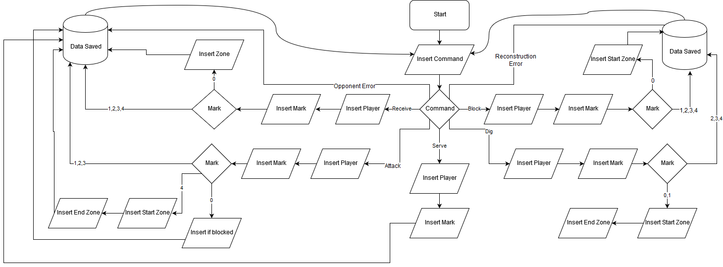
There are also special commands : "Cancel entry" allows you to start over again the entry of the command, "Take notes" opens a blocknote to write anything, " Delete " allows you to delete the commands entered since the last entry .
Clarification on the commands "Reconstruction error" and "Opponent error".
"Reconstruction error" is used to register a point immediately for an error that is not automatically taken by the program commands. For example, a serve error is automatically recorded by a serve with a double negative vote, while errors such as double hits, a free ball that falls and other errors of this kind can be recorded with this button. The same applies to "Opponent Error", also including their double negative serves or attacks, since they are not automatically registered by the program.
The score :
The score is updated automatically by the program, so you always have the score at your fingertips as a useful continuous check to verify that you have entered the data correctly. In case we have forgotten something, it is possible to calibrate the score with the "+" and "-" keys above it.

Displaying data during the game:
A very useful function, especially if you are in direct contact with the coach during the game, is the ability to view data during the game (total and current set). This can be done individually for each player (by pressing the button with the name of the player concerned), and overall by team with the menu buttons at the top of the window (Serve, Receive, Attack, Block, Dig, Suffered Points, Statistical indexes) .

The backup function:
Each time a command is entered, the software saves the current state of the game in a serialized file within the main directory. In this way, if the program is closed for any reason during the execution, the data will not be lost. In fact, in the presence of this file, when the program is restarted, you will be asked if you want to restore that session.

End of the match:
When the game is over we can use the "Match ended" command, the output window will be opened to process the data.

Output Window:
This is the window that appears after entering the command "Match Ended", you will be asked to enter some data, you can see the preview of the data detected with the "Preview" button and you can return to the Main Window with "Go back". When we have filled all the fields and want to process the data, click on the "Finish" button. At this point the program ends and we will have our data in a folder in the main directory.
Output files:
In the output folder we will have 3 files:
a html file with the game name: Allows to display all the collected data in the browser intuitively, it also has a navigation menu.
e -mailList.txt: Contains the list of emails recognized by the identifiers of the players, they are already separated by ";" so you can directly paste them as recipients of an email containing the data.
gameData.lotusgame: This file is vital. It is the file that contains all the collected data serialized so that the various programs can recognize and use them. In particular it is used by SSA Lotus as a backup file, from Analyzer as a file of the game, from Data Modder is the file that we actually read and modify.

Once we have the folder in the root directory we can move it to the "Games" folder, with the hierarchy that best suits us.

Let's get to the specifics: Lotus Scout Analyzer
This software allows you to put together and view data from multiple games. From the top left navigator we can select a folder (all the games will be taken inside that folder and subfolders) or more files with the extension ".lotusgame" with the multiple selection (also applicable to the folders). The root of the browser is the "Games" folder in the main directory, so if the folder is removed or renamed the program will not be able to find the games. The fact that you can conveniently select a folder invites you to use an intelligent hierarchy of the sub-folders of "Games". When we have selected what interests us we can click on "Load the games in this folder". At this point on the right we have a report of the files that have been recognized and loaded. The summary data of the matches will appear. Clicking on the buttons of the various skills will open a graph that will show the average of this skill in the various games. The "Export the processed data" button creates an html file in the main directory, containing all the data in detail, in the exact same format as the html files of the individual games. The "View the data of a single player" button will open a similar window, related to only one particular player (selectable from the drop-down menu), you can click several times and open more windows, in order to compare more players with each other.

Let's get to the specifics: Lotus Data Modder
This program has three main functions: update game files to the latest version, edit player identifiers, edit data for a single game.

Match file update:
We drag the interested folder into the area indicated at the top left (it works as a Scout Analyzer: it will search for the .lotusgame files in all the subfolders). At this point we click on "Update all files": in this way all the files will be loaded and processed again, which allows, in case a new version of the program has been modified to print in html, to recreate the html file with those data, but with the html printing functions of the new program. Example: In version 1 of the program the headers of the tables were blue, in version 2 of the program they are pink. If I load the files produced by version 1 in the Data Modder of version 2, the files will be reprinted with the pink headers.

Change the identifiers:
WARNING: this operation is very risky if you do not know exactly what you are doing! In particular, giving an identifier that already uses another player would mix the data of the two players irreversibly (if not manually with the single files) !

You drag the folder to the area with the same procedure for updating the match files. At this point we click on "Change identifier".
You will be asked to enter the identifier you want to change and the new one. Without any checks, all matches of the old identifier will be replaced with the new one. Useful if a player had a temporary identifier or changed e-mail address.

Edit data of a match:
We drag the .lotusgame file of the game that we want to modify in the upper left area. At this point all the editable data of the game will appear. To change the data you need to know a detail of how the data are saved by the program. To simplify the algorithms, the program saves the data in three types of data structures: one dedicated to the total data, those dedicated to the sets and those dedicated to the individual rotations. From the drop-down menus we can navigate and edit data within these data structures. But if, for example, we modify something in a data structure we will also have to manually modify the other two if we want to keep the data consistent. When we are finished we can click on the "Save" button. At this point the .lotusgame file will be modified, and the old html file (if present in the same folder as the .lotusgame file) replaced by the new one.

